**2025 County Budget Workshops**

Join DLG Staff as they provide budget information and answer questions to prepare county officials for best practices in budget preparation and management. The workshops are designed for newly elected officials, as well as a refresher course for veteran office holders. Each DLG workshop will provide three (3) hours of HB 810 training credits for those participating.

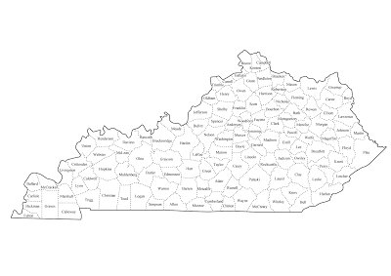**Pre-registration is required** to help staff plan for allotted space and materials. Register here… [2025 Budget Workshop Registration](https://docs.google.com/forms/d/e/1FAIpQLSesT86CE0rlrAPMFxKjeDlP93pwAFS5KoXu_UrJ5EZm3bpm8w/viewform?usp=preview)

**Workshop Schedule:**

9 a.m. – Noon – DLG Budget Workshop (Local Time)

**Dates & Locations:**

2/4/25 Cumberland Valley ADD CVADD Offices, London

2/11/25 Northern Kentucky ADD NKADD Offices, Florence

2/13/25 Bluegrass Region KYTC Conference Center, Frankfort

2/19/25 Gateway ADD GADD Offices, Morehead

2/25/25 Purchase ADD PADD Office, Mayfield

2/26/25 Barren River ADD BRADD Offices, Bowling Green

2/27/25 Green River ADD GRADD Offices, Owensboro

